Text Set
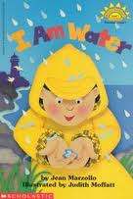
Lesson 1: Water & The Three States of Matter
I Am Water By: Jean Marzollo
Simple text and colorful illustrations combine that dedicates each page to the usefulness of water.
Marzollo, J. (1996). I am water. New York: Scholastic, Inc.

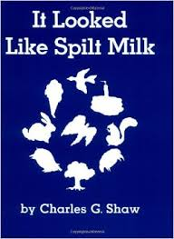
Lesson 4: Clouds
It Looked Like Spilt Milk by Charles G. Shaw
Simple shapes on each page that brings up questions to if the shapes are of animals or if it is just made from spilt milk. This relates to cloud formation as children use their imagination to see different shapes in clouds.
Shaw, C. G., & Row, P. (1947). It looked like spilt milk. New York: Harper & Row.
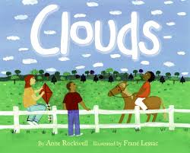
Lesson 4: Clouds
Clouds by Anne Rockwell
The book encourages readers to take a look out their windows when wondering what the weather will be. The pages introduce how the types of clouds can forecast weather.
Rockwell, A. F., & Lessac, F. (2008). Clouds. New York: Collins.
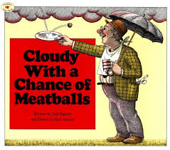
Lesson 5: Weather
Cloudy With a Chance of Meatballs by Judi Barrett
The story is about rain falling from the sky. The rain… is actually food! What is it like to have food fall from the sky?
Barrett, J., & Barrett, R. (1988). Cloudy with a chance of meatballs. New York: Atheneum.

